***TWITTER WHOIS INFORMATION***

***Domain information***

Domain: twitter.com

Registar: CSC Corporate Domains, Inc.

Expires On: 2023-01-21

Updated On: 2022-01-17

Status: Client transfer prohibited.

Server delete prohibited.

Server transfer prohibited.

Server update prohibited.

Name Servers: a.r06.twtrdns.net, b.r06.twtrdns.net, c.r06.twtrdns.net, d.r06.twtrdns.net, d01-01.nstwtrdns.net, d01-02.nstwtrd.net, ns3.p34.dynect.net, ns4.p34.dynect.net.

***Technical Contact***

Name: Domain Admin.

Organization: Meta Platforms, Inc.

Street: 1601 Willow Rd

City: Menio Park.

State: CA

Postal Code: 94025

Phone: +1.6505434800

Email: [domain@fb.com](mailto:domain@fb.com)

***A LOOK AT THE EVOLUTION OF TWITTER***

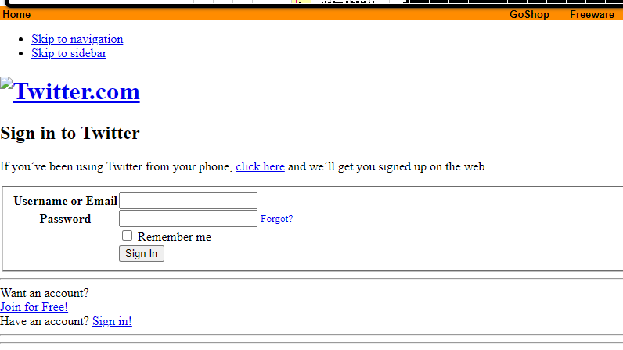

Figure : This is twitter in March 2 2001.

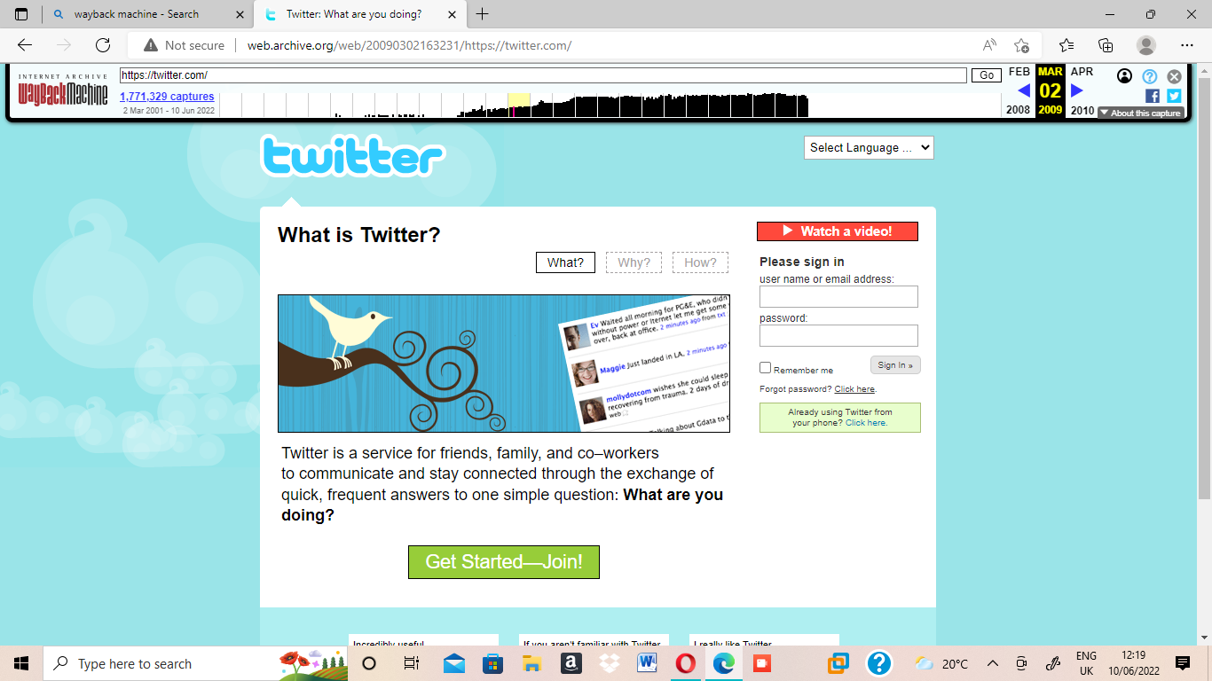

Figure :This is twitter in March 2 2009.

.

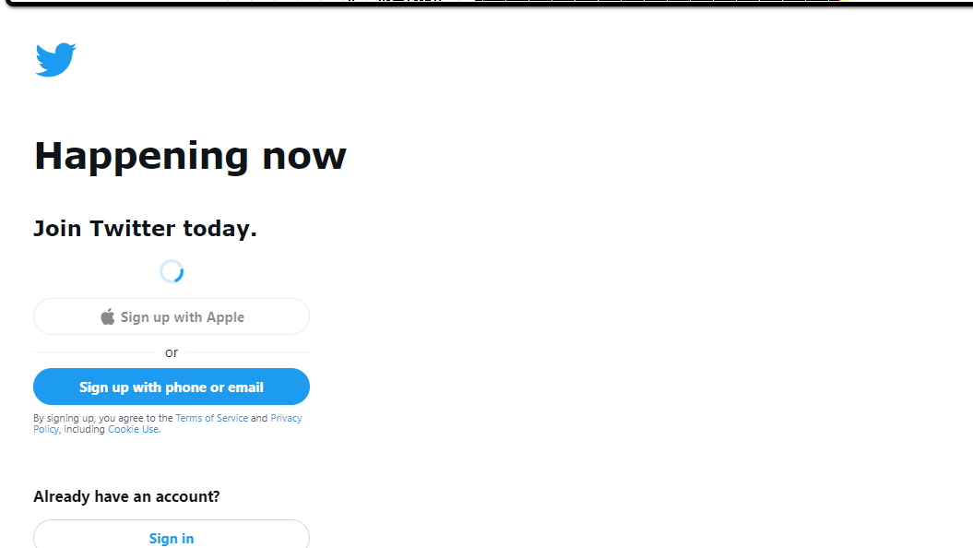

Figure : This is Twitter Today on 10 June 2022.

***FACEBOOK WHOIS INFORMATION***

***Domain Information***

Domain: facebook.com

Registrar: RegistrarSafe, LLC

Registered On: 1997-03-29

Expires On: 2031-03-30

Updated On: 2022-01-26

Status: clientDeleteProhibited

clientTranferProhibited

clientUpdateProhibited

serverDeleteProhibited

serverUpdateProhibited

Name Servers: a.ns.facebook.com, b.ns.faceboo.com, c.ns.facebook.com, d.ns.facebook.com.

***REGISTRANT CONTACT***

Name: Domain Admin

Organization: Meta Platforms, Inc

Street: 1601 Willow Rd

City: Menlo Park

Postal Code: 94025

Country: US

Phone: +1.6505434800

Email: domain@fb.com

***THIS IS A LOOK AT THE EVOLUTION OF FACEBOOK***

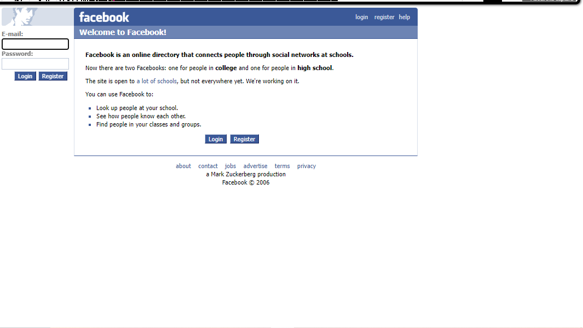

Figure : This is Facebook in 17 Feb 2006.

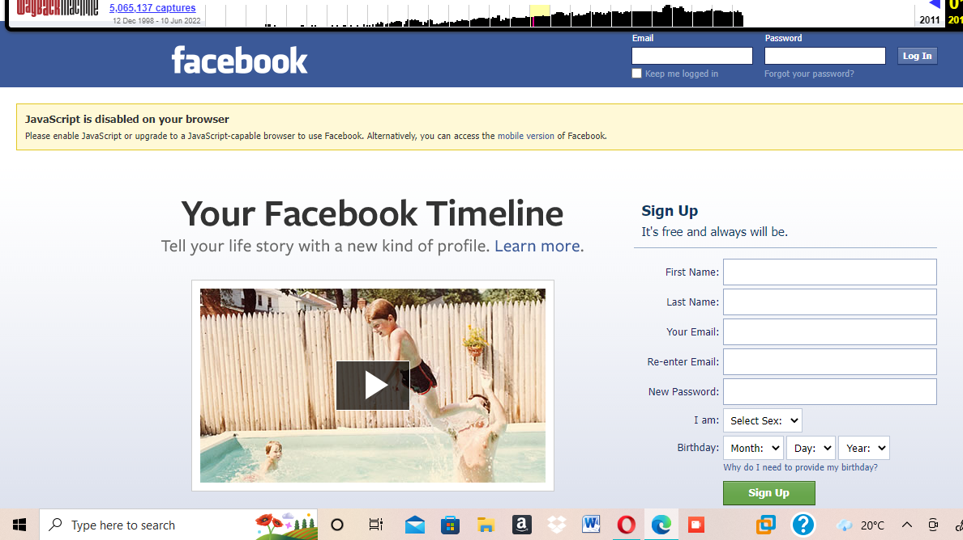

Figure : This is Facebook in 01 Feb 2012.

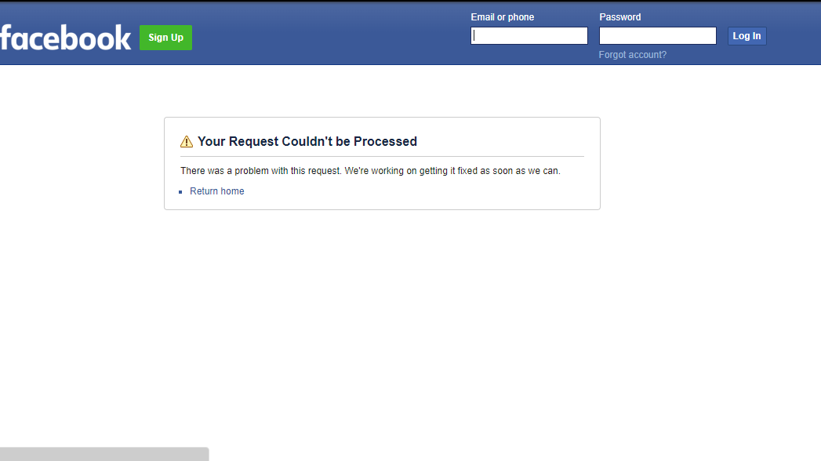

Figure : This is Facebook in 10 June 2022.